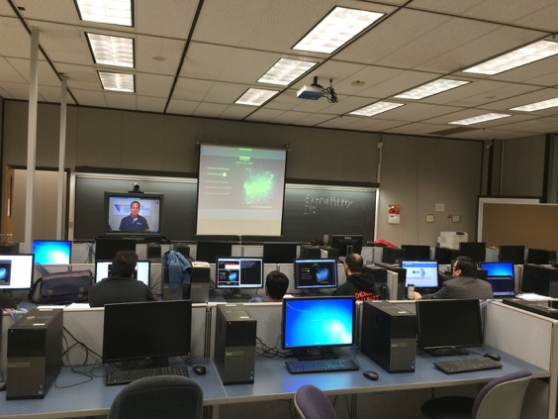CIS AT-A-GLANCE

Leads to the Associate’s degree or Bachelor’s degree

**Includes courses in:**

* Programming Languages
* C++, Python
* Database Management Systems
* Communications & Networking
* Systems Analysis

**Allows a wide variety of electives, including:**

• Operating Systems

• LINUX/UNIX

• E-commerce

• Network Security

• Java, VB.Net, ASP.Net

• Oracle, MySQL, MS SQL Server

• Web Programming

**Provides experience on these platforms:**

• Personal Computers (Microsoft Windows)

• Unix/Linux

• VM environments

**Contact us for more information:**

Robert Kramer,

CIS Coordinator

rwkramer@ysu.edu

(330) 941.3468

Dr. Kriss A. Schueller, Chair

kaschueller@ysu.edu

(330) 941.3379



**Department of Computer Science and Information Systems**

Youngstown State University One University Plaza

Youngstown, Ohio, 44555

(330) 941.3134

www.csis.ysu.edu





**Undergraduate Program**

**Computer Information Systems**

**Unlock Your Future**

QUICK FACTS

**Degrees:**

Associate in Applied Science (AAS)

Bachelor of Science in Applied Science (BSAS)

**Four-Year Degree Minors:**

• Business

• Accounting

• Management

• Geography

• Professional Writing and Editing

• Others as noted in the YSU Bulletin

**Lab Facilities:**

• Five General-use Intel Platform

• Advanced Multimedia

• Two Cisco Networking

• Wireless

• PC Maintenance/Troubleshooting

• Operating Systems

• UNIX/Graphics (Sun)

**Faculty:**

• Broad-based industry experience

• Security certified

ABOUT THE DEPARTMENT

The CSIS office is located in 339 Meshel Hall. Most of the classrooms and labs in which our classes are taught are located on the first three floors of Meshel Hall.

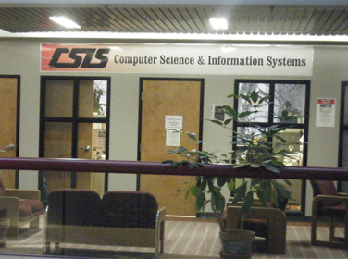

Some of our labs are general-purpose facilities that house computers using Windows and standard application packages, including Microsoft Word, Internet Explorer, and Visual Studio.

Other labs include more specialized software and hardware, including multimedia packages and networking equipment.

We offer a safe studying environment. Our labs are restricted to students of and students taking departmental classes.

ABOUT THE PROGRAM

The Computer Information Systems (CIS) program covers both technical and end-user aspects of computing. The courses cover applications programming, databases, networking, systems analysis, and other areas of importance for the design and use of information systems in businesses.

The program also includes courses in Accounting, Mathematics, and Professional & Technical Communication.

The program is set up in “2+2” format. Students who wish to do so may begin with the Associate Degree program (AAS) and then, upon completing that degree, move into the Bachelor’s degree program (BSAS). The program is also available as a regular Bachelor’s degree program, without the Associate Degree.

Many of the courses in the program contain lab components, allowing the students to gain hands-on experience.

Our majors have found interesting links between the CIS major and some of the University’s minors, including Geography, Business, Professional Writing and Editing, and Management Information Systems.

CAREER OPPORTUNITIES

• Applications Programmer

• Data Warehouse Programmer

• Network Specialist

• Database Administrator

• Web Programmer

• Systems Analyst

**Department of Computer Science and Information Systems**